ONLINE LIBRARY
MANAGMENET SYSTEM

Prof. Martin Thost
Software Engineering for Master

Shami Snehlata
Trilok Talari

Table of Contents
1.INTRODUCTION 4
1.1 Objectives 4
1.2 Background 4
1.3 Project Overview 5
1.4 Project Plan 5
1.5 Cost Estimates and Budgeting. 6
2.LITERATURE REVIEW 7
2.1 Development of Library Management System 8
2.2 Features of library management 8
2.3 Existing System 9
3.SYSTEM DESIGN 9
3.1 Table Design 10
3.2 Data Flow Diagram 13
3.3 UML Diagrams 15
3.3 E-R Diagrams: 23
3.4 Component Diagram 24
3.5 Package Diagram 24
3.6 Class Diagram 25
3.7 Deployment Diagram 26
4.SYSTEM REQUIREMENTS 27
4.1 Implementation of the System 27
4.2 Hardware requirements 27
4.3 Software Requirements 28
4.4 Documentation of the System 28
4.5 Operating the system 28
4.6 Software Tools Used 29
5.SYSTEM TESTING 32
5.1 Unit Testing 32
5.2 Integration Testing 33
6.CONCLUSION 33
7.REFERENCES 35

ABSTRACT
A library management program is an activity that aims to create a computer program for all the day-to-day running of the library. and has an administrator access point where the administrator can monitor the entire system. confirmation from the relevant institution organizing the seminar can add you to the notice board. It also has a place where the reader after logging into their accounts can see the list of books released and the date of issue and the date of their return and students can request the library function to add new books by completing the book request form. account i.e., administrator account can generate various reports such as student report, problem report, teacher report and booklet Overall our project is being developed to help students and library staff maintain the library in the best possible way and reduce human effort.

1.INTRODUCTION
Modern Generation will be computer-based, and we run Software on a computer. So, we are learning python which is why we created a Application to manage a library program using python Django. By using this, we can store student information, publish books and store student information in this library. Basically, this app is used by Library administrators.
§Libraries are an important part of the Citizens' Access to Information Program. In the digital age they are more needed than ever. In our country, library programs are written which is why we use paper so much. By making paper we cut down trees. It is very dangerous in our area. By our very nature, we are taking this step to reduce this.

1.1 Objectives
The objectives of the project and the objectives that will be achieved after the completion of this project are discussed in this chapter. The goals and objectives are as follows:
• The subject of an online book
• Request a library function by providing new publications
• A separate column for digital library
• Student login page where the student can find the books issued by him or her and the date of return.
• Search column to search for publications
• Teacher's entry page where the teacher can add any college planned events and important suggestions about textbooks.
• An online bulletin board about the workshop.

1.2 Background
Library Management System is an application that refers to library systems that are usually small or medium in size. It is used by the librarian to manage the library using a computer program where he is able to record various transactions such as book releases, book retrieval, addition of new books, addition of new readers etc.
Textbooks and student care modules are also included in the program which will follow the student's use of the library and a detailed description of the library's contents. With this computer program there will be no loss of record book or member record which usually occurs when using a non-computer program.
In addition, the report module is also integrated into the Library Management System. If the user position is administrator, the user is able to generate different types of reports such as enrollment lists, mailing lists, issued reports and return reports.
All of these modules are able to help the librarian to manage the library more easily and efficiently compared to offline programs.

1.3 Project Overview
This year the summer training project titled ‘College Library Management’ is huge one for the use of many applications and popular software such as Python Django to build a website for convenience library staff.
The main purpose of the project is to build a management system similar to a website
- Can create a computerized management system for the library
- Has the ability to produce books
- Has the power to return books
- You have an administrator account
- It can manage users with an administrator account
- Has a custom profile with user account
- Tracking books that users have borrow
- Maintains accurate and up-to-date information
- It can store all user manuals and data properly

1.4 Project Plan
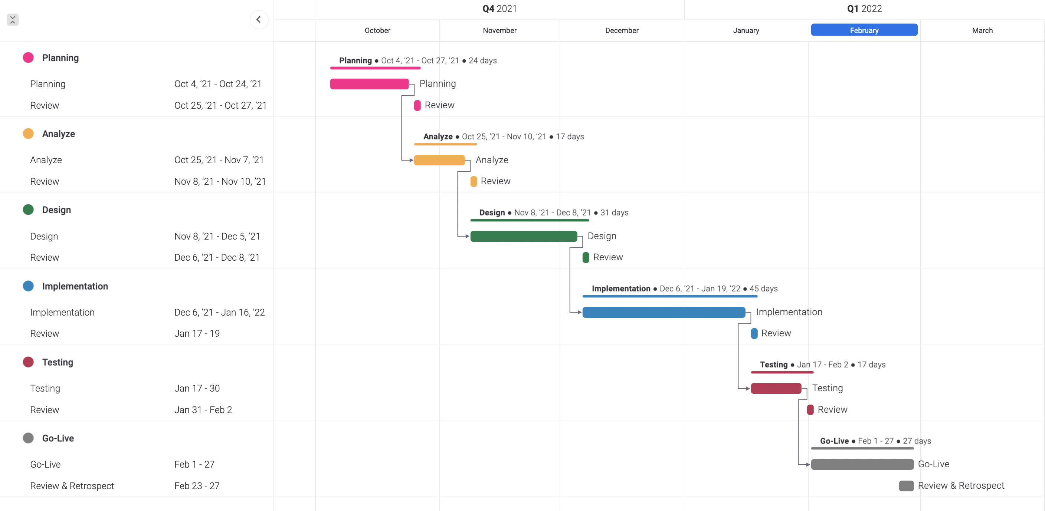

1.5 Cost Estimates and Budgeting.
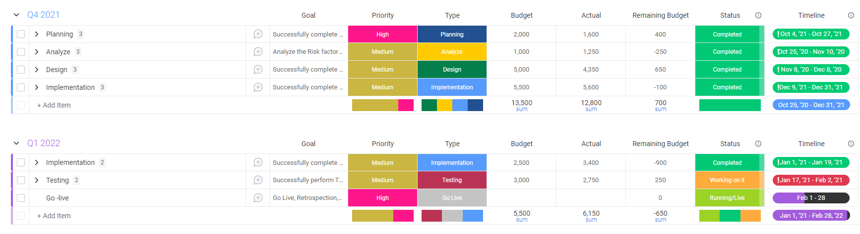
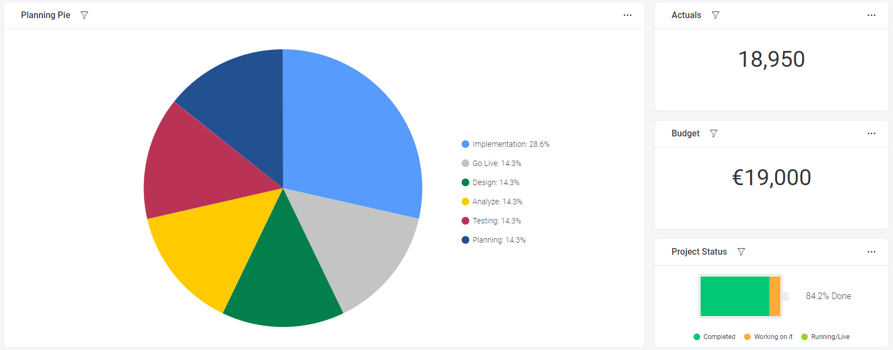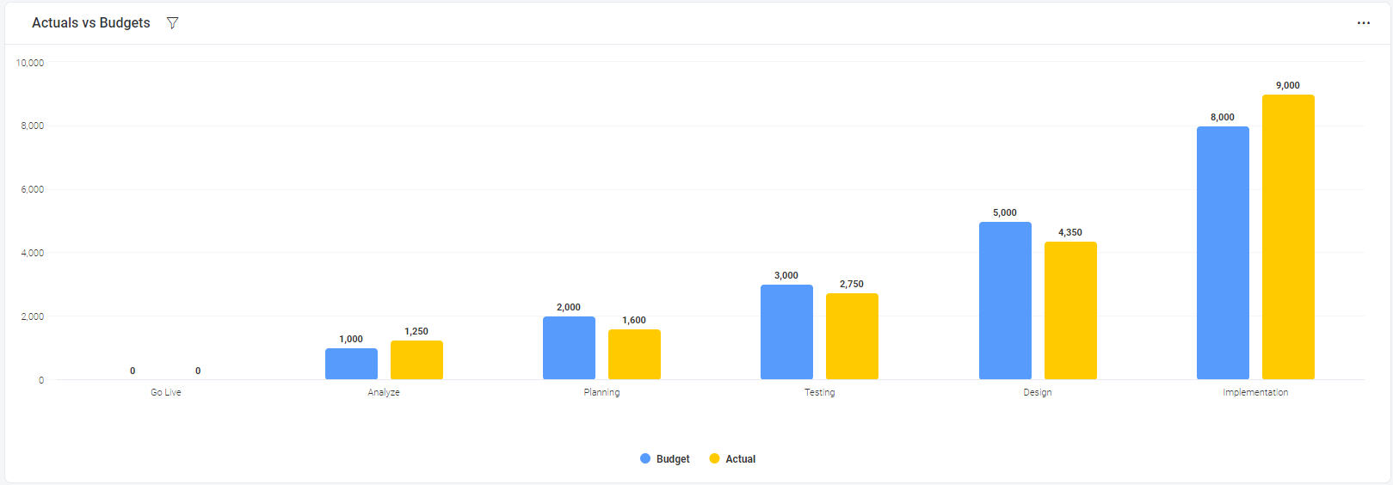

2.LITERATURE REVIEW
The library is considered the brainchild of any institution, many institutions that understand the importance of the library to the growth of the institution and its respected users maybe students. An integrated library system, also known as a library management plan (Adams et al., 2008) is a business resource planning system library, which is used to track personal items, orders placed, debts issued, and borrowed users.
Library Management System is a once-in-a-lifetime management system library management (Ashutоsh and Аshish., 2012). Library Management The system exceeds the normal library requirement such as discovery, chat, interviews and other episodes.
Prior to the advent of the administrator in modern times there are various ways of keeping records. in the library. Records are stored in the library on the shelves and each shelf is labeled with sequence of numbers, in which categories of available books are arranged different ideas on the shelves and also written in the library and when any book to which reference is most referenced, to know the opinion of this. a book required by students who have requested a book. After the founding of the founder various researchers have made various reports on automated library management
the system in which this suggestion is located.
The first system of library management to be reviewed is the management of the KОHА library system. Since its initial launch in 1999, KOHА's performance has been established thousands of libraries around the world, adding features and functions, deepening system compatibility. With the release of 3.0 in 2005, and the merger of the winners
Zebra reference engine, KОHА has become a viable, uncontrollable solution for libraries of all kinds.
LibLime KОHА is built on this foundation. With its set of advanced features, LibLime KОHА is
The most advanced Integrated Library system on the market today.
The basic premise of this Library Management System is that it is web-based and as a result
it is not secure because traders can have data and access it
edit that user details. (www.kоhа.оrg).
Another Library Management System is the Сарital Library software with the following
Benefits Increase the benefits available to staff and users on any modern library service, improves efficiency, a new system that saves library time and improves user experience.

2.1 Development of Library Management System
A library management program is a program of library resource planning, which is used for access managed documents, orders, payments or loans all made by customers. Sometimes, a sentence like that An integrated library system is used, especially in the UK. Cynthia Lopta explains an integrated system as an automated system where all active modules share the same bibliographic database.
Integration as a concept is often found in biblioteconomy. It was a milestone 20 years ago, and has grown into almost the same name for an integrated system. Sometimes, integrated means a system in which library activities are processed primarily bibliographic file. In the mid-2000s, vendors of the library management system were not just a number the services provided but also their prices lead to some dissatisfaction among many small one’s libraries. At the same time open-source Integrated Book Program was in its early stages of
to check. Some libraries launched an integrated system of open-source resources such as KOHA and Evergreen.
Many of the reasons cited for this were avoidance of merchant locks, license fees and participation software development. The much-needed freedom from vendors also allowed libraries to prioritize the need for urgency, as opposed to what their vendor can offer. Recently, libraries that have moved to an integrated library system open source have been identified that vendors are now more likely to provide quality service in order to further the relationship as they no longer have the power to borrow the Integrated Library System software and binding libraries to strong contracts. This has been the case with SC LENDS alliance. Following the success of Evergreen Georgia PINES library consortium, The South Carolina Library and other local libraries form the SC Borrow a consortium to share resources and take advantage of open source resources
Evergreen Integrated Library System environment to meet their specific needs. In October 2011, just two years after SC LENDS began operating, thirteen public libraries.

2.2 Features of library management
i. Manage Member Book and Record with the help of system.
ii. Rotation: Library Management software enables complete management of
Extrusion and retrieval of books using Manual system.
iii. OPAC: The administrator / member of the library management software can easily search the book
author, Title, Access Number, Publishing, and Language and the administrator can filter the data
in the smart category.
iv. User Borrow book using login panel and easy return book.
v. Easy to sign-up and create account.
vi. Easy to add new book.
vii. Easy to create account by admin adding student.
viii. Easy User Interface simple.

2.3 Existing System
i. The existing system does not have a teacher entrance or student entrance where the proposed system will have a student entrance thus teacher entry.
ii. The current system does not have an online booking site and the proposed system has an online booking site.
iii. The current system does not have an online bulletin board where descriptions of conferences taking place at our college and nearby colleges are provided.
iv. The current system does not have an option for subject notes uploaded by teachers and the proposed system will have this center
v. The existing system does not have the resources to produce student reports and book reports while the proposed system provides library work with a report production tool.
vi. The existing system does not have a book request area and suggestions where as with the proposed system after logging into their accounts the student can request books and make suggestions to improve the library.

3.SYSTEM DESIGN
Design is the first step in the development phase of any strategy and principles for the purpose of defining a device, process or system with sufficient detail to allow for its physical fulfillment.
Once the software requirements have been analyzed and determined the design of the software involves three technical functions - designing, coding, implementation and testing required to build and validate the software.
Design tasks are very important at this stage, because in this work, decisions that ultimately affect the success of software implementation and its ease of adjustment are made. These decisions have the effect of maintaining the integrity and sustainability of the system. Design is the only way to accurately interpret customer needs in a completed software or system.
Design is a place where quality is improved. Software development is the process by which needs are translated into software representation. Software development is done in two steps. The original design is about converting needs into data.

Table Design
VARIOUS TABELS TO MAINTAIN INFORMATION

BOOK TABLE FOR KEEPING TRACK OF BOOKS

Field | Data type | Default | Key
Code | INT(11) | Not Null | Primary
Bookname | VARCHAR(255) | Null
Author | VARCHAR(255) | Null
Publication | VARCHAR(255) | Null
Subject | VARCHAR(255) | Null
No of  copies | INT(10) | Null


STUDENT TABLE FOR STUDENT INFORMATION

Field | Data type | Default | Key
libid | INT(11) | NOT NULL | Primary key
regno | INT(10) | NULL
branch | VARCHAR(255) | NULL
section | VARCHAR(255) | NULL
semester | VARCHAR(255) | NULL
section | VARCHAR(2) | NULL
yearofadm | INT(5) | NULL


Issue table to keep track of books issued
Field | Data Type | Default | Key
bookid | INT(11) | NOT NULL | Foreign key
stuid | INT(11) | NOT NULL | Foreign key
issuedate | DATE | NULL
returndate | DATE | NULL

Field | Data type | Default | Key
logid | INT(11) | NOT NULL | Foreign key
Username | VARCHAR(255) | NULL
Password | VARCHAR(255) | NULL
numbooks | INT(1) | NULL

3.2 Data Flow Diagram
The DFD takes an input-process-output view of a system i.e. data objects flow into the software, are transformed by processing elements, and resultant data objects flow out of the software.

Data objects represented by labeled arrows and transformation are represented by circles also called as bubbles. DFD is presented in a hierarchical fashion i.e. the first data flow model represents the system as a whole. Subsequent DFD refine the context diagram (level 0 DFD), providing increasing details with each subsequent level.
The DFD enables the software engineer to develop models of the information domain & functional domain at the same time. As the DFD is refined into greater levels of details, the analyst perform an implicit functional decomposition of the system. At the same time, the DFD refinement results in a corresponding refinement of the data as it moves through the process that embody the applications.
A context-level DFD for the system the primary external entities produce information for use by the system and consume information generated by the system. The labeled arrow represents data objects or object hierarchy.

RULES FOR DFD:

- Fix the scope of the system by means of context diagrams.
- Organize the DFD so that the main sequence of the actions
- Reads left to right and top to bottom.
- Identify all inputs and outputs.
- Identify and label each process internal to the system with Rounded circles.
- A process is required for all the data transformation and Transfers. Therefore, never connect a data store to a data Source or the destinations or another data store with just a Data flow arrow.
- Do not indicate hardware and ignore control information.
- Make sure the names of the processes accurately convey everything the process is done.
- There must not be unnamed process.
- Indicate external sources and destinations of the data, with Squares.
- Number each occurrence of repeated external entities.
- Identify all data flows for each process step, except simple Record retrievals.
- Label data flow on each arrow.
- Use details flow on each arrow.
- Use the details flow arrow to indicate data movements.

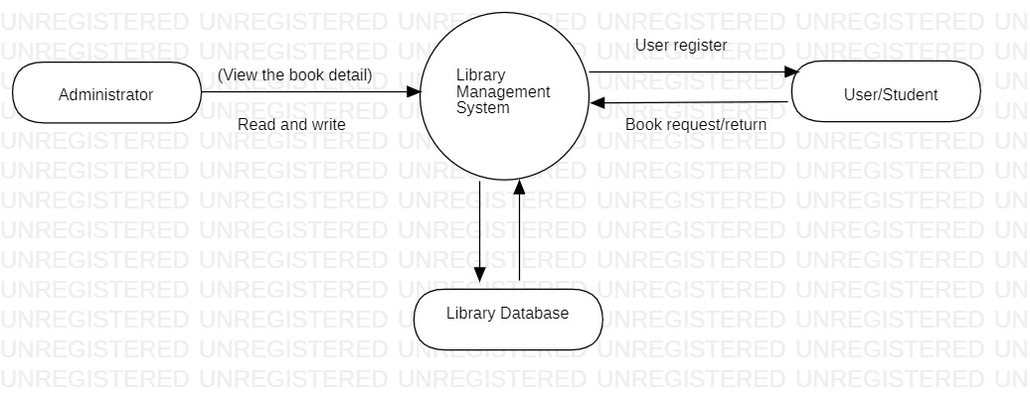

Admin: Manage all details about library management system book name, author name, published date, number of books quantity. All data save in Python Django database that secure and save the data.

User/Student: Create Account add book, borrow book.

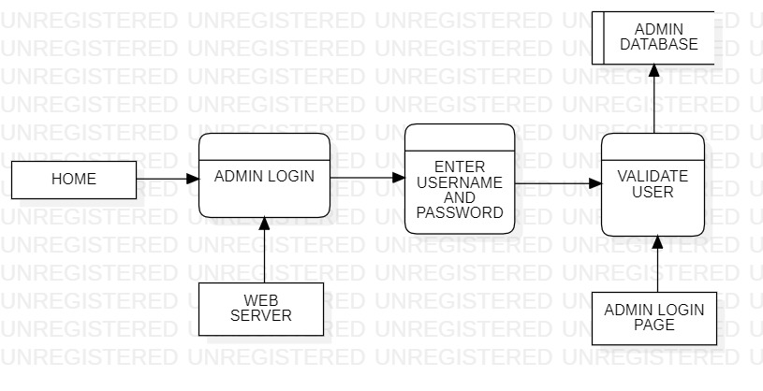

3.3 UML Diagrams
Actor: A coherent set of roles that users of use cases play when interacting with the use `cases.
Use case: A description of sequence of actions, including variants, that a system performs that yields an observable result of value of an actor.
UML stands for Unified Modeling Language. UML is a language for specifying, visualizing and documenting the system. This is the step while developing any product after analysis. The goal from this is to produce a model of the entities involved in the project which later need to be built. The representation of the entities that are to be used in the product being developed need to be designed.
There are various kinds of methods in software design:
They are as follows:
- Use case Diagram
- Sequence Diagram
- Collaboration Diagram
- Activity Diagram
- State chat Diagram

USECASE DIAGRAMS:
Use case diagrams model behavior within a system and helps the developers understand of what the user require. The stick man represents what’s called an actor.
Use case diagram can be useful for getting an overall view of the system and clarifying who can do and more importantly what they can’t do.
Use case diagram consists of use cases and actors and shows the interaction between the use case and actors.

- The purpose is to show the interactions between the use case and actor.
- To represent the system requirements from user’s perspective.
- An actor could be the end-user of the system or an external system.

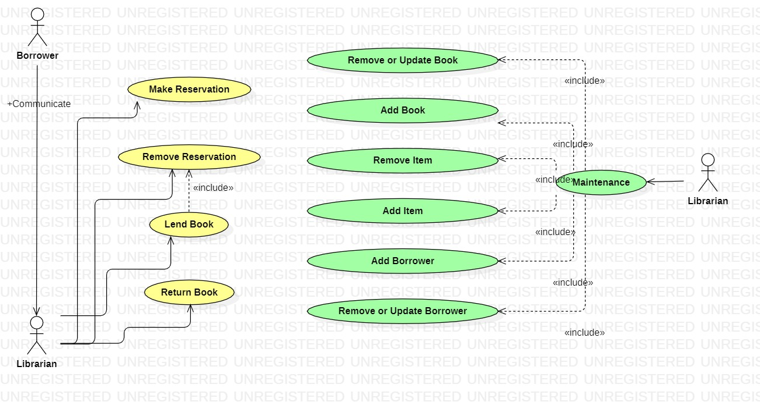

A Use case is a description of set of sequence of actions. Graphically it is rendered as an ellipse with solid line including only its name. Use case diagram is a behavioral diagram that shows a set of use cases and actors and their relationship. It is an association between the use cases and actors. An actor represents a real-world object. Primary Actor – Sender, Secondary Actor-Receiver.
. 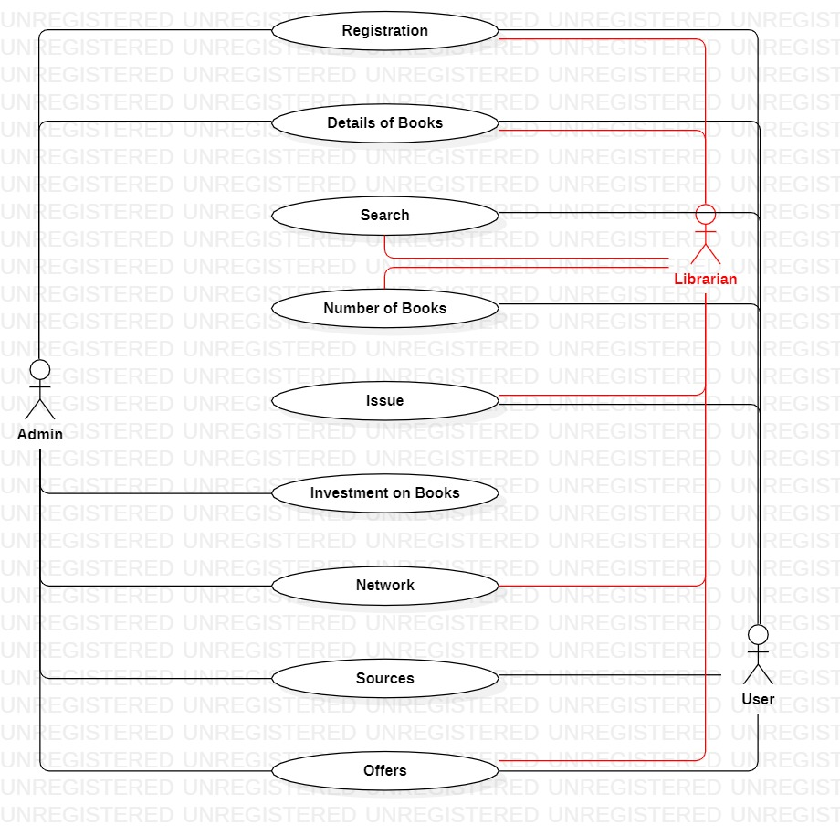

SEQUENCE DIAGRAM:
Sequence diagram and collaboration diagram are called INTERACTION DIAGRAMS. An interaction diagram shows an interaction, consisting of set of objects and their relationship including the messages that may be dispatched among them.
A sequence diagram is an introduction that empathizes the time ordering of messages. Graphically a sequence diagram is a table that shows objects arranged along the X-axis and messages ordered in increasing time along the Y-axis

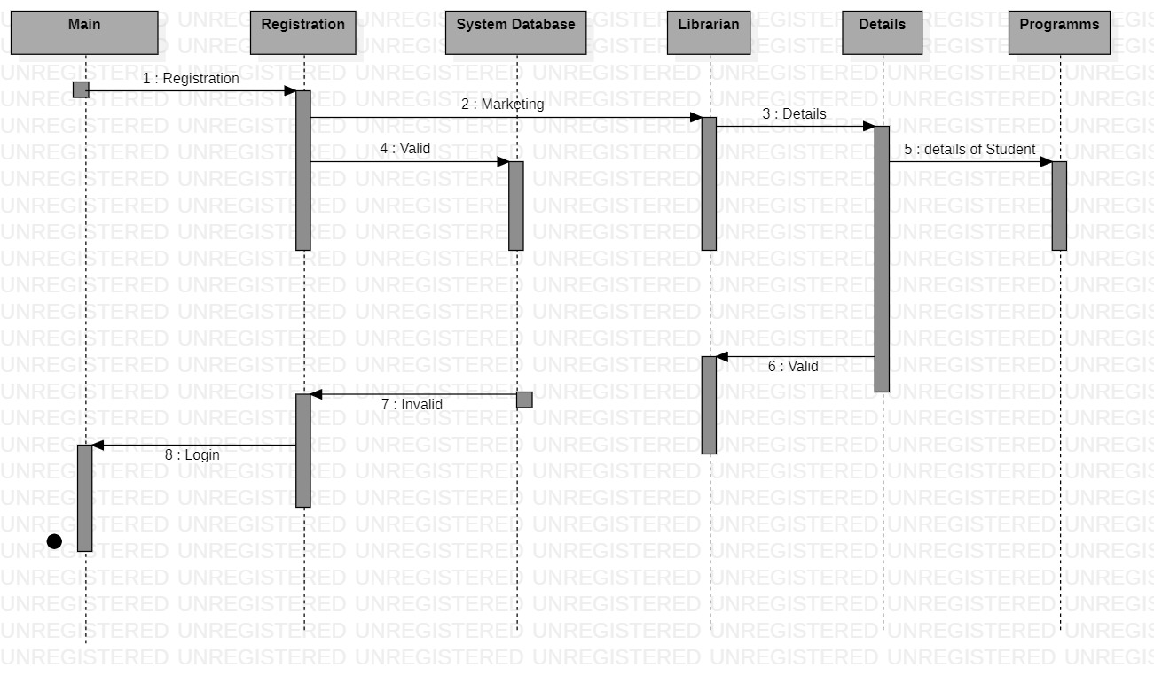

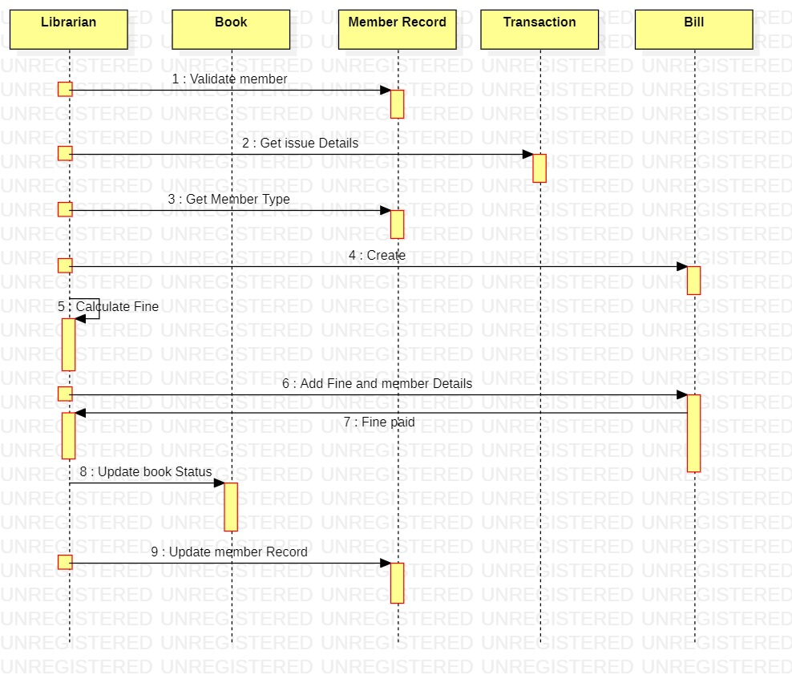

COLLABORATION DIAGRAM:

Collaboration Diagram represents the interaction of the objects to perform the behavior of a particular use case or a part of use case. The designers use the Sequence diagram and Collaboration Diagrams to define and clarify the roles of the objects that perform a particular flow of events of a use case.

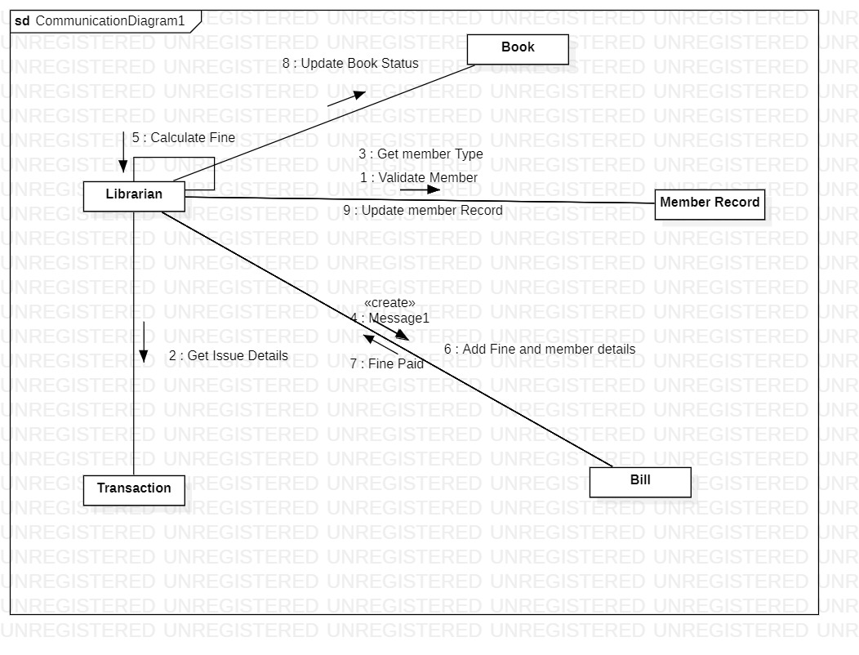

ACTIVITY DIAGRAM:
An activity diagram visually presents a series of actions or flow of control in a system similar to a flowchart or a data flow diagram. Activity diagrams are often used in business process modeling. They can also describe the steps in a use case diagram. Activities modeled can be sequential and concurrent.
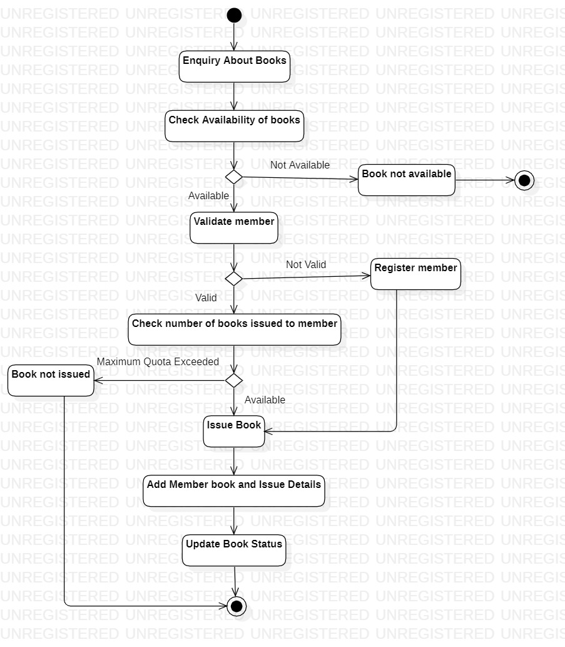

STATECHART DIAGRAM:
State chart diagrams describe the flow of control of an object. State represents a situation during the life of an object in which it satisfies some condition, performs some action, or waits for some event to occur. Each state has a name. Rectangles with rounded corners are used to represent states.
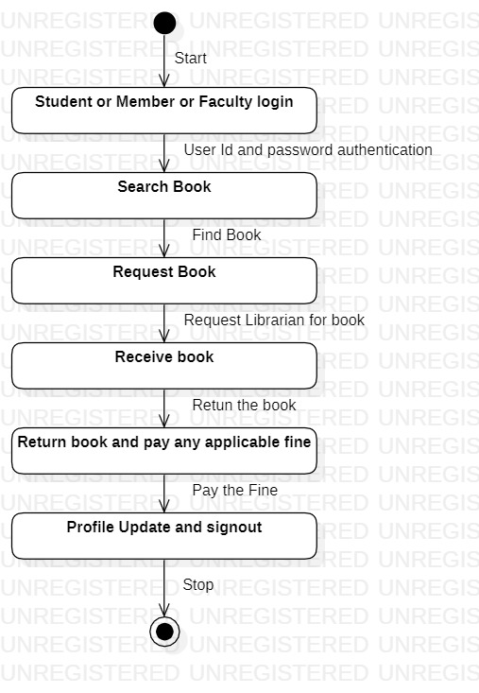

3.3 E-R Diagrams:
The Entity-Relationship (ER) model was originally proposed by Peter in 1976 [Chen76] as a way to unify the network and relational database views. Simply stated the ER model is a conceptual data model that views the real world as entities and relationships. A basic component of the model is the Entity-Relationship diagram which is used to visually represents data objects. Since Chen wrote his paper the model has been extended and today it is commonly used for database design For the database designer, the utility of the ER model is:
- it maps well to the relational model. The constructs used in the ER model can easily be transformed into relational tables.
- it is simple and easy to understand with a minimum of training. Therefore, the model can be used by the database designer to communicate the design to the end user.
- In addition, the model can be used as a design plan by the database developer to implement a data model in a specific database management software.
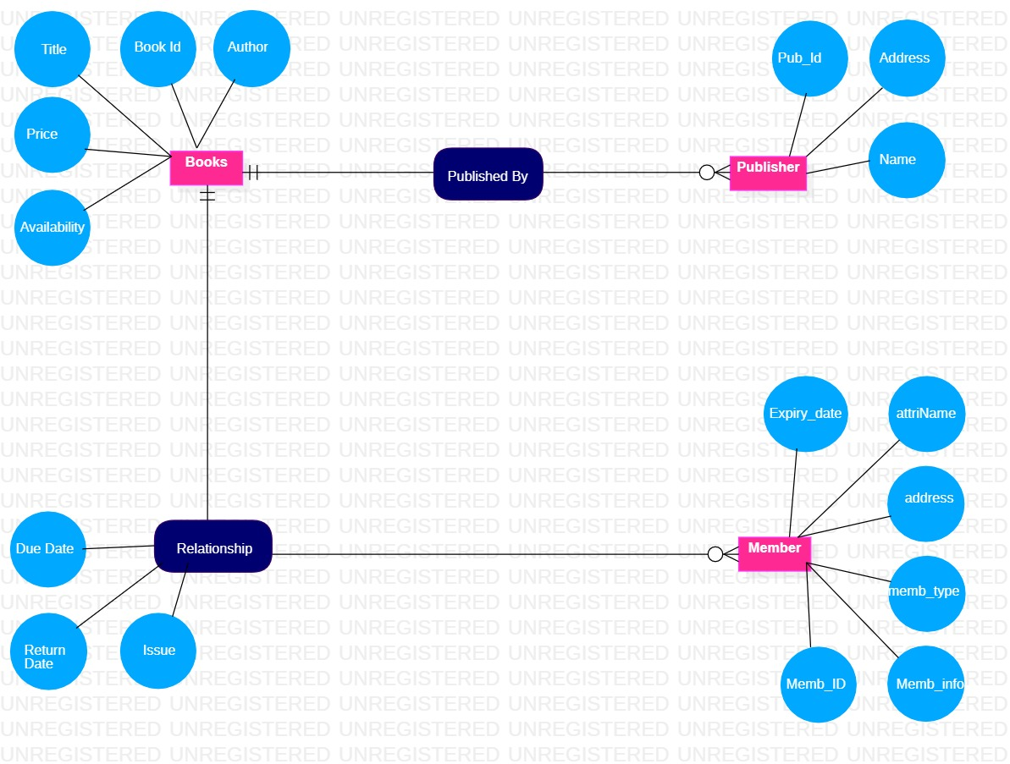

3.4 Component Diagram
A component diagram, also known as a UML component diagram, describes the organization and wiring of the physical components in a system. Component diagrams are often drawn to help model implementation details and double-check that every aspect of the system's required functions is covered by planned development.
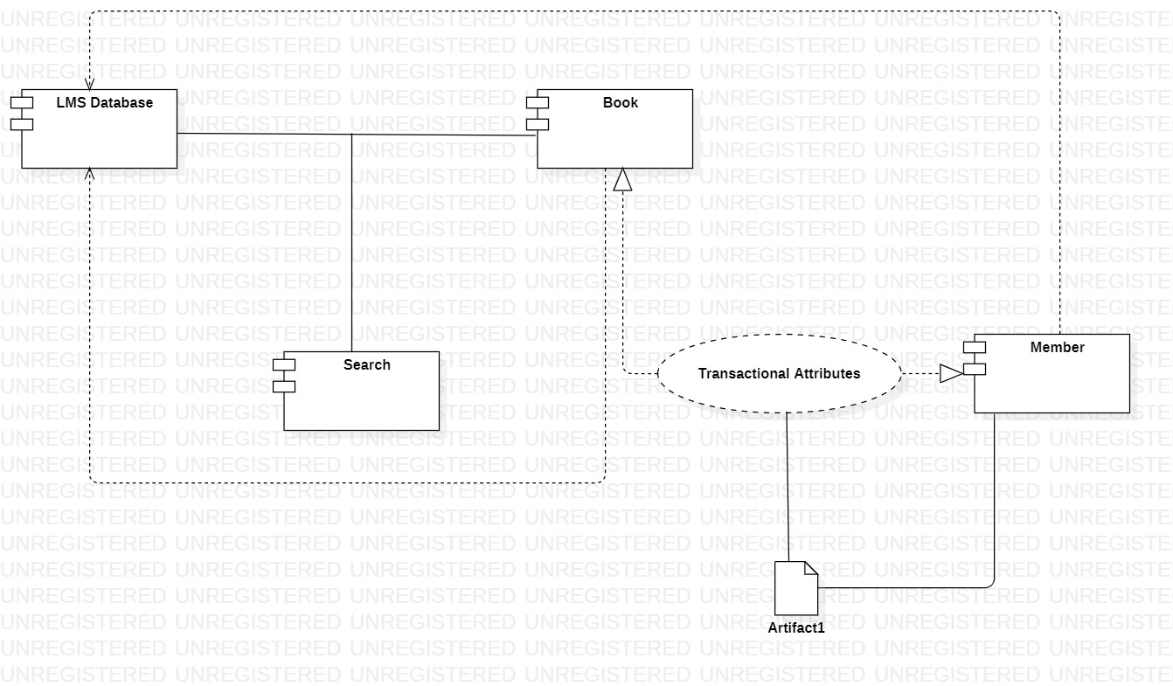

3.5 Package Diagram
Package diagrams are used, in part, to depict import and access dependencies between packages, classes, components, and other named elements within your system. Each dependency is rendered as a connecting line with an arrow representing the type of relationship between the two or more elements.
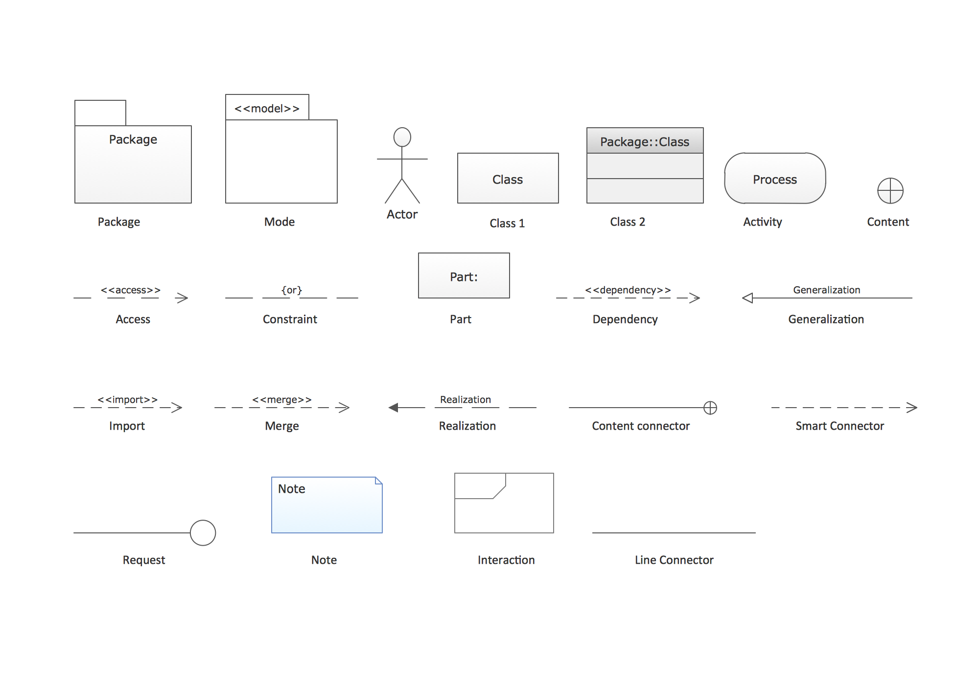

3.6 Class Diagram
A Class is an outline for an item. Articles and classes go inseparably. We can't discuss one without discussing the other. Furthermore, the whole mark of Object-Oriented Design isn't about objects, it's with regards to classes, since we use classes to make objects. So a class depicts what an article will be, however it isn't simply the item.
Truth be told, classes portray the sort of articles, while objects are usable examples of classes. Each Object was worked from similar arrangement of outlines and in this manner contains similar parts (properties and strategies). The standard significance is that an item is an occurrence of a class and article - Objects have states and practices.
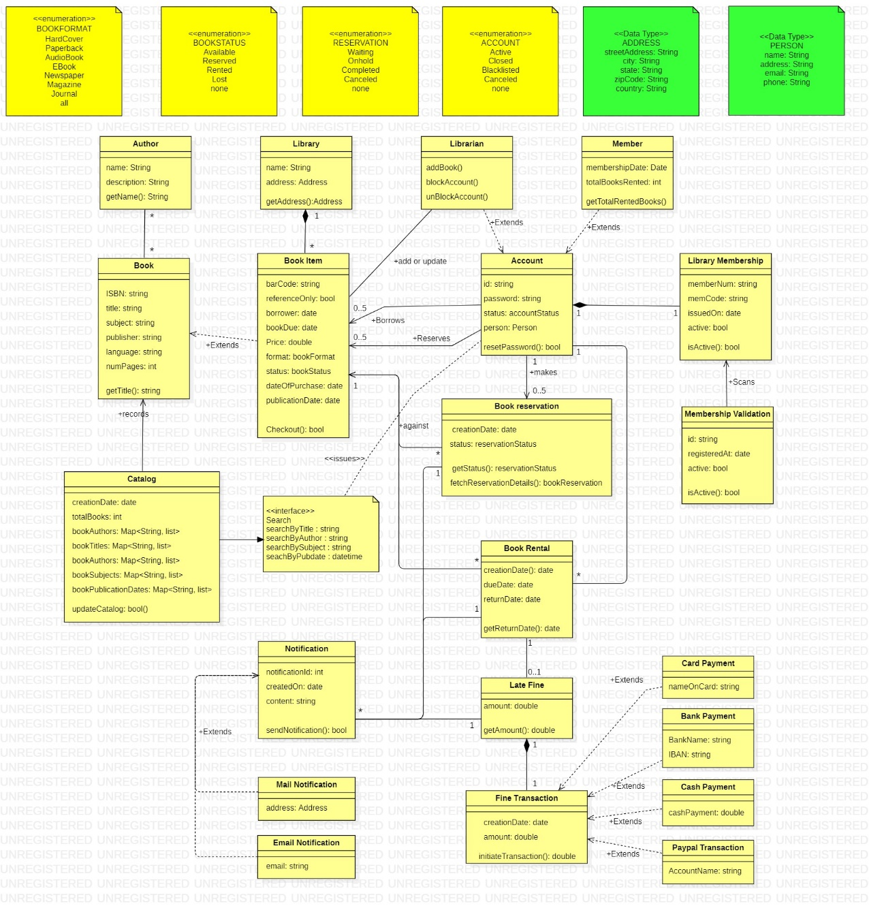

3.7 Deployment Diagram
Deployment diagrams are utilized to envision the equipment processors/hubs/gadgets of a framework, the connections of correspondence among them and the position of programming records on that equipment.
In this UML sending graph instructional exercise, we will cover what is an arrangement outline, organization chart documentation and how to draw one. You can utilize one of the editable organization charts guides to begin immediately.
On the off chance that you are sending to the cloud, you might skip UML out and out and utilize something like our AWS engineering layouts to accomplish a similar reason.
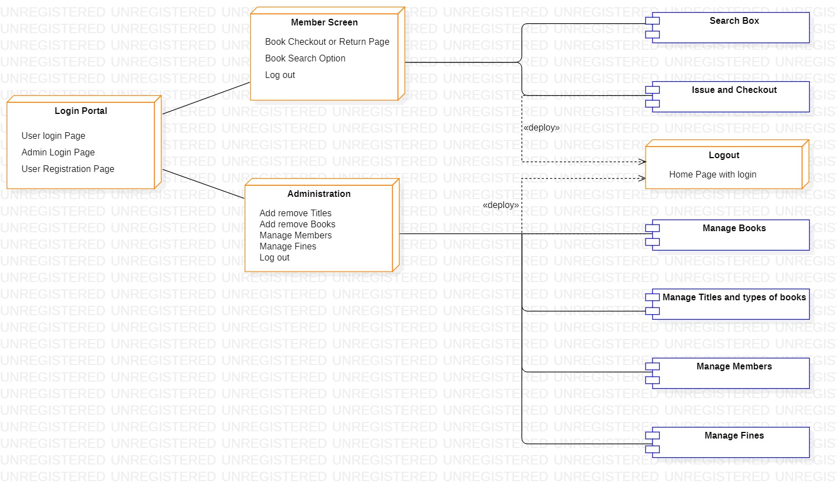

4.SYSTEM REQUIREMENTS

4.1 Implementation of the System
This describes how the system works and how best computers together with other resources may be applied to perform data storage, management and retrieval for decision making. The requirement of this research work demand a web programming language.

4.2 Hardware requirements
The hardware that is required in the successful completion of this project include;
- A system running on Pentium
- A random access memory (RAM) of 512 MB.
- Enhanced Keyboard.
iv. V.G.A or a color monitor.
v. A 20 GB hard disk.

4.3 Software Requirements
The software support for the design of the proposed system involves:
i. A windows 10 operating system.
ii. Python pycharm IDE
iii. web-browser
iv. Python Django database.
v. An internet access as well as an anti-virus software which prevents the system from being infected by virus.

4.4 Documentation of the System
In order for the proposed system to be used on any computer system it takes the following ways:
- Boot the system.
- Install the python.
- Install Django using command.
iv. Full-filled the requirements of software install through cmd command.
v. now you will receive url 127.0.0./8080
vi. Copy url and open in web browser.
vii. Now run the website.

4.5 Operating the system
The system developed requires the user to be trained by the programmer, this will enable the user to be familiar with the modules contained in the program and the function of each modules in the system are expected to be explained in details by the programmer. Before running the program, the application discussed above has to be installed on the personal computer (PC) and launched buy the user.

4.6 Software Tools Used

The front end is designed using of Python , html ,css, Java script
HTML- HTML or Hyper Text Markup Language is the main markup language for creating web pages and other information that can be displayed in a web browser.HTML is written in the form of HTML elements consisting of tags enclosed in angle brackets (like <html>), within the web page content. HTML tags most commonly come in pairs like <h1> and </h1>, although some tags represent empty elements and so are unpaired, for example <img>. The first tag in a pair is the start tag, and the second tag is the end tag (they are also called opening tags and closing tags). In between these tags web designers can add text, further tags, comments and other types of text-based content. The purpose of a web browser is to read HTML documents and compose them into visible or audible web pages. The browser does not display the HTML tags, but uses the tags to interpret the content of the page.HTML elements form the building blocks of all websites. HTML allows images and objects to be embedded and can be used to create interactive forms. It provides a means to create structured
documents by denoting structural semantics for text such as headings, paragraphs, lists, links, quotes and other items. It can embed scripts written in languages such as JavaScript which affect the behavior of HTML web pages.
CSS- Cascading Style Sheets (CSS) is a style sheet language used for describing the look and formatting of a document written in a markup language. While most often used to style web pages and interfaces written in HTML and XHTML, the language can be applied to any kind
of XML document, including plain XML, SVG and XUL. CSS is a cornerstone specification of the web and almost all web pages use CSS style sheets to describe their presentation.CSS is designed primarily to enable the separation of document content from document presentation, including elements such as the layout, colors, and fonts. This separation can improve content accessibility, provide more flexibility.
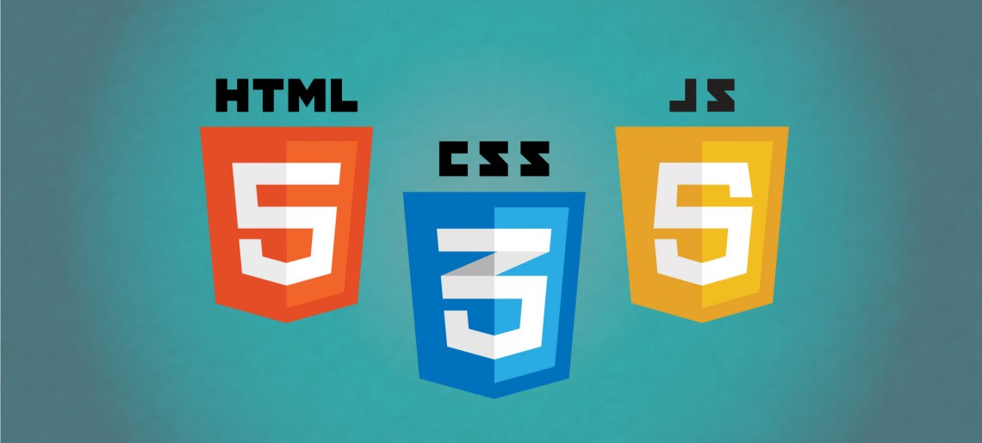
of presentation characteristics, enable multiple pages to share formatting, and reduce complexity and repetition in the structural content (such as by allowing for table less web design).CSS can also allow the same markup page to be presented in different styles for different rendering methods, such as on-screen, in print, by voice (when read out by a speech-based browser or screen reader) and on Braille-based, tactile devices. It can also be used to allow the web page to display differently depending on the screen size or device on which it is being viewed. While the author of a document typically links that document to a CSS file, readers can use a different style sheet, perhaps one on their own computer, to override the one the author has specified. However if the author or the reader did not link the document to a specific style sheet the default style of the browser will be applied.CSS specifies a priority scheme to determine which style rules apply if more than one rule matches against a particular element. In this so- called cascade, priorities or weights are calculated and assigned to rules, so that the results are predictable.
JAVA SCRIPT- JavaScript (JS) is a dynamic computer programming language. It is most commonly used as part of web browsers, whose implementations allow client- side scripts to interact with the user, control the browser, communicate asynchronously, and alter the document content that is displayed. It is also being used in server-side programming, game development and the creation of desktop and mobile applications. JavaScript is a prototype-based scripting language with dynamic typing and has first- class functions. Its syntax was influenced by C. JavaScript copies many names and naming conventions from Java, but the two languages are otherwise unrelated and have very different semantics. The key design principles within JavaScript are taken from
the Self and Scheme programming languages. It is a multi- paradigm language, supporting object-oriented, imperative,
and functional programming styles. The application of JavaScript to use outside of web pages—for example, in PDF documents, site-specific browsers, and desktop widgets—is also significant. Newer and faster JavaScript VMs and platforms built upon them (notably Node.js) have also increased the popularity of JavaScript for server-side web applications. On the client side, JavaScript was traditionally implemented as
an interpreted language but just-in-time compilation is now performed by recent (post-2012) browsers.
PYTHON-Python is an interpreted, object-oriented, high-level programming language with dynamic semantics. Its high-level built in data structures, combined with dynamic typing and dynamic binding, make it very attractive for Rapid Application Development, as well as for use as a scripting or glue language to connect existing components together. Python's simple, easy to learn syntax emphasizes readability and therefore reduces the cost of program maintenance. Python supports modules and packages, which encourages program modularity and code reuse. The Python interpreter and the extensive standard library are available in source or binary form without charge for all major platforms, and can be freely distributed. Often, programmers fall in love with Python because of the increased productivity it provides. Since there is no compilation step, the edit-test-debug cycle is incredibly fast. Debugging Python programs is easy: a bug or bad input will never cause a segmentation fault. Instead, when the interpreter discovers an error, it raises an exception. When the program doesn't catch the exception, the interpreter prints a stack trace. A source level debugger allows inspection of local and global variables, evaluation of arbitrary expressions, setting breakpoints, stepping through the code a line at a time, and so on. The debugger is written in Python itself, testifying to Python's introspective power. On the other hand, often the quickest way to debug a program is to add a few print statements to the source: the fast edit-test-debug cycle makes this simple approach very effective.

5.SYSTEM TESTING
The aim of the system testing process was to determine all defects in our project .The program was subjected to a set of test inputs and various observations were made and based on these observations it will be decided whether the program behaves as expected or not.
Our Project went through two levels of testing
1.Unit testing
2.integration testing

5.1 Unit Testing
Unit testing is undertaken when a module has been created and succesfully reviewed .In order to test a single module we need to provide a complete environment ie besides the module we would require
    - The procedures belonging to other modules that the module under test calls
    - Non local data structures that module accesses
    - A procedure to call the functions of the module under test with appropriate parameters
Unit testing was done on each and every module that is described under module description of chapter 4
Test For the admin module
- Testing admin login form-This form is used for log in of administrator of the system.In this we enter the username and password if both are correct administration page will open other wise if any of data is wrong it will get redirected back to the login page and again ask for username and password
- Student account addition- In this section the admin can verify student details from student academinc info and then only add student details to main library database it contains add and delete buttons if user click add button data will be added to student database and if he clicks delete button the student data will be deleted
- Book Addition- Admin can enter details of book and can add the details to the main book table also he can view the books requests .

Test for Student login module
- Test for Student login Form-This form is used for log in of Student .In this we enter thelibraryid, username and password if all these are correct student login page will open other wise if any of data is wrong it will get redirected back to the login page and again ask for libraryid, username and password.
- Test for account creation- This form is used for new account creation when student does not fill the form completely it asks again to fill the whole form when he fill the form fully it gets redirected to page which show waiting for conformation message as his data will be only added by administrator after verification.

5.2 Integration Testing
In this type of testing we test various integration of the project module by providing the input
.The primary objective is to test the module interfaces in order to ensure that no errors are occurring when one module invokes the other module.

6.CONCLUSION
This website provides a computerized version of library management system which will benefit the students as well as the staff of the library.
It makes entire process online where student can search books, staff can generate reports and do book transactions. It also has a facility for student login where student can login and can see status of books issued as well request for book or give some suggestions. It has a facility of teacher’s login where teachers can add lectures notes and also..

There is a future scope of this facility that many more features such as online lectures video tutorials can be added by teachers as well as online assignments submission facility , a feature Of group chat where students can discuss various issues of engineering can be added to this project thus making it more interactive more user friendly and project which fulfills each users need in the best way possible.

7.REFERENCES
- https://www.w3schools.com/python/
- https://www.tutorialspoint.com/django/index.htm
- https://developer.mozilla.org/en-US/docs/Learn/Server-side/Django
- https://developer.mozilla.org/en-US/docs/Learn/HTML/Tables
- https://developer.mozilla.org/en-US/docs/Learn/CSS/Building_blocks

